*Part 2 of this tutorial for detecting your custom objects is available via this*[*link*](https://medium.com/deepquestai/train-object-detection-ai-with-6-lines-of-code-6d087063f6ff)*.*

https://miro.medium.com/max/60/1*VXZ8CamGG2Z0M0N4t0Fmng.jpeg?q=20

One of the important fields of Artificial Intelligenceis Computer Vision. Computer Vision is the science of computers and software systems that can recognize and understand images and scenes. Computer Vision is also composed of various aspects such as image recognition, object detection, image generation, image super-resolution and more. Object detection is probably the most profound aspect of computer vision due the number practical use cases. In this tutorial, I will briefly introduce the concept of modern object detection, challenges faced by software developers, the solution my team has provided as well as code tutorials to perform high performance object detection.

Object detection refers to the capability of computer and software systems to locate objects in an image/scene and identify each object. Object detection has been widely used for face detection, vehicle detection, pedestrian counting, web images, security systems and driverless cars. There are many ways object detection can be used as well in many fields of practice. Like every other computer technology, a wide range of creative and amazing uses of object detection will definitely come from the efforts of computer programmers and software developers.

Getting to use modern object detection methods in applications and systems, as well as building new applications based on these methods is not a straight forward task. Early implementations of object detection involved the use of classical algorithms, like the ones supported in OpenCV, the popular computer vision library. However, these classical algorithms could not achieve enough performance to work under different conditions.

The breakthrough and rapid adoption of deep learning in 2012 brought into existence modern and highly accurate object detection algorithms and methods such as R-CNN, Fast-RCNN, Faster-RCNN, RetinaNet and fast yet highly accurate ones like SSD and YOLO. Using these methods and algorithms, based on deep learning which is also based on machine learning require lots of mathematical and deep learning frameworks understanding. There are millions of expert computer programmers and software developers that want to integrate and create new products that uses object detection. But this technology is kept out of their reach due to the extra and complicated path to understanding and making practical use of it.

My team realized this problem months ago, which is why I and [John Olafenwa](https://medium.com/@johnolafenwa)built **[ImageAI](https://github.com/OlafenwaMoses/ImageAI" \t "_blank)** , a python library that lets programmers and software developers easily integrate state-of-the-art computer vision technologies into their existing and new applications, using just few lines of code.

**[OlafenwaMoses/ImageAI](https://github.com/OlafenwaMoses/ImageAI?source=post_page-----d6cb4d86f606----------------------)**

[ImageAI - A python library built to empower developers to build applications and systems with self-contained Computer…](https://github.com/OlafenwaMoses/ImageAI?source=post_page-----d6cb4d86f606----------------------)

[github.com](https://github.com/OlafenwaMoses/ImageAI?source=post_page-----d6cb4d86f606----------------------)

To perform object detection using **ImageAI,**all you need to do is

1. Install Python on your computer system
2. Install **ImageAI**and its dependencies

3. Download the Object Detection model file

4. Run the sample codes (which is as few as 10 lines)

**Now let’s get started.**

**1)** Download and install Python 3 from official Python Language website

[https://python.org](https://python.org/)

**2)** Install the following dependencies via pip:

i. Tensorflow

**pip install tensorflow**

ii. Numpy

**pip install numpy**

iii. SciPy

**pip install scipy**

iv. OpenCV

**pip install opencv-python**

v. Pillow

**pip install pillow**

vi. Matplotlib

**pip install matplotlib**

vii. H5py

**pip install h5py**

viii. Keras

**pip install keras**

ix. **ImageAI**

pip3 install imageai --upgrade

**3)** Download the RetinaNet model file that will be used for object detection via this [link](https://github.com/OlafenwaMoses/ImageAI/releases/download/1.0/resnet50_coco_best_v2.0.1.h5).

Great. Now that you have installed the dependencies, you are ready to write your first object detection code. Create a Python file and give it a name (For example, **FirstDetection.py**), and then write the code below into it. Copy the RetinaNet model file and the image you want to detect to the folder that contains the python file.

**FirstDetection.py**

Then run the code and wait while the results prints in the console. Once the result is printed to the console, go to the folder in which your **FirstDetection.py**is and you will find a new image saved. Take a look at a 2 image samples below and the new images saved after detection.

**Before Detection:**

https://miro.medium.com/max/60/1*v0Bm-HQxWtpbQ0Yq463uqw.jpeg?q=20

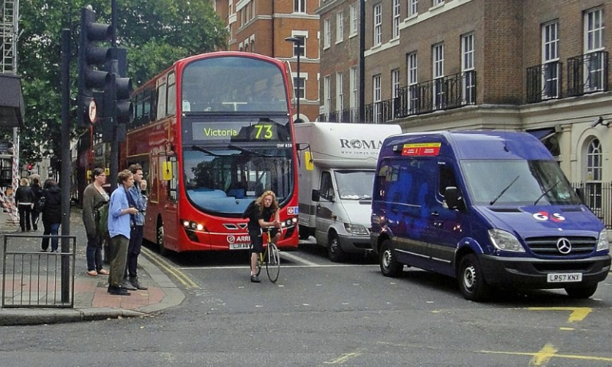

Image Credit: alzheimers.co.uk

https://miro.medium.com/max/60/1*zoS8E7Gooe_-3Hi43_R_Yg.jpeg?q=20

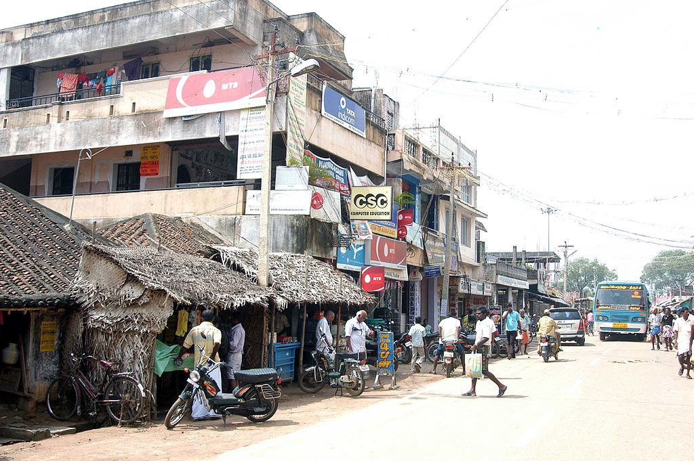

Image Credit: Wikicommons

**After Detection:**

https://miro.medium.com/max/60/1*VXZ8CamGG2Z0M0N4t0Fmng.jpeg?q=20

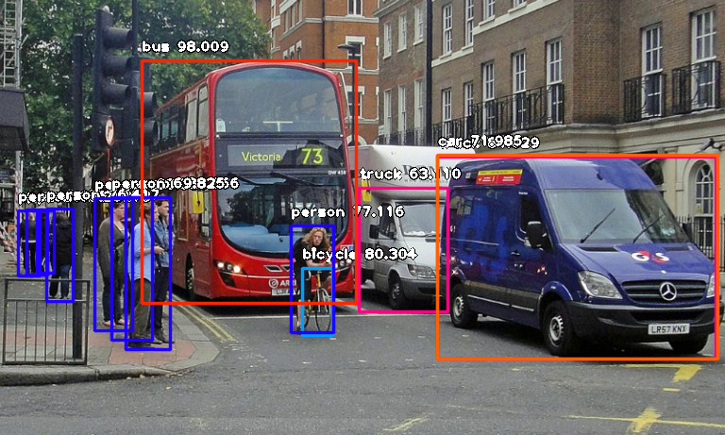

***Console result for above image:***

person : 55.8402955532074

person : 53.21805477142334

person : 69.25139427185059

person : 76.41745209693909

bicycle : 80.30363917350769

person : 83.58567953109741

person : 89.06581997871399

truck : 63.10953497886658

person : 69.82483863830566

person : 77.11606621742249

bus : 98.00949096679688

truck : 84.02870297431946

car : 71.98476791381836

https://miro.medium.com/max/60/1*6pWgk9wWgPsOM4nExSM2mw.jpeg?q=20

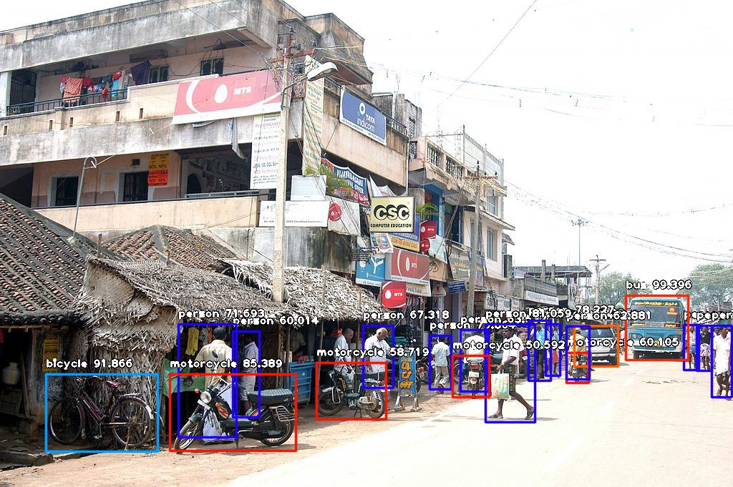

***Console result for above image:***

person : 71.10445499420166

person : 59.28672552108765

person : 59.61582064628601

person : 75.86382627487183

motorcycle : 60.1050078868866

bus : 99.39600229263306

car : 74.05484318733215

person : 67.31776595115662

person : 63.53200078010559

person : 78.2265305519104

person : 62.880998849868774

person : 72.93365597724915

person : 60.01397967338562

person : 81.05944991111755

motorcycle : 50.591760873794556

motorcycle : 58.719027042388916

person : 71.69321775436401

bicycle : 91.86570048332214

motorcycle : 85.38855314254761

Now let us explain how the 10-line code works.

In the above 3 lines, we imported the **ImageAI**object detection class in the first line, imported the python **os**class in the second line and defined a variable to hold the path to the folder where our python file, RetinaNet model file and images are in the third line.

In the 5 lines of code above, we defined our object detection class in the first line, set the model type to RetinaNet in the second line, set the model path to the path of our RetinaNet model in the third line, load the model into the object detection class in the fourth line, then we called the detection function and parsed in the input image path and the output image path in the fifth line.

In the above 2 lines of code, we iterate over all the results returned by the **detector.detectObjectsFromImage**function in the first line, then print out the name and percentage probability of the model on each object detected in the image in the second line.

**ImageAI**supports many powerful customization of the object detection process. One of it is the ability to extract the image of each object detected in the image. By simply parsing the extra parameter **extract\_detected\_objects=True** into the **detectObjectsFromImage**function as seen below, the object detection class will create a folder for the image objects, extract each image, save each to the new folder created and return an extra array that contains the path to each of the images.

Let us apply it to the first image and see some of the images from the result below:

https://miro.medium.com/max/28/1*NWpD9sBt7dJ_sPdIDAY5Vg.jpeg?q=20

https://miro.medium.com/max/32/1*NWpD9sBt7dJ_sPdIDAY5Vg.jpeg

https://miro.medium.com/max/52/1*f8YJmAmHH3RUuLwE9PydmQ.jpeg?q=20

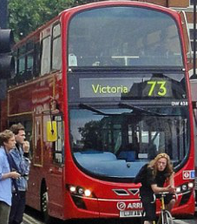

https://miro.medium.com/max/60/1*qs6SUf7n70Mc7xtxnDTYbg.jpeg?q=20

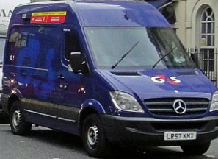

https://miro.medium.com/max/44/1*1ixIvQuvIhD_zy1u74NmTQ.jpeg?q=20

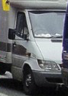

https://miro.medium.com/max/60/1*J4aXi8U7oo0Ty1DEXAL3Rw.jpeg?q=20

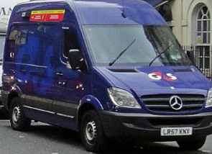

All the pictures of the pedestrians were extracted has well. I did not include all of them has they will take unnecessary space.

*To detect your own kind of objects, visit the tutorial linked below.*

**[Train Object Detection AI with 6 lines of code](https://medium.com/deepquestai/train-object-detection-ai-with-6-lines-of-code-6d087063f6ff?source=post_page-----d6cb4d86f606----------------------)**

[Step-by-step tutorial on training object detection models on your own dataset](https://medium.com/deepquestai/train-object-detection-ai-with-6-lines-of-code-6d087063f6ff?source=post_page-----d6cb4d86f606----------------------)

[medium.com](https://medium.com/deepquestai/train-object-detection-ai-with-6-lines-of-code-6d087063f6ff?source=post_page-----d6cb4d86f606----------------------)

**ImageAI**provides many more features useful for customization and production capable deployments for object detection tasks. Some of the features supported are:

- **Adjusting Minimum Probability:**By default, objects detected with a probability percentage of less than 50 will not be shown or reported. You can increase this value for high certainty cases or reduce the value for cases where all possible objects are needed to be detected.

- **Custom Objects Detection:**Using a provided CustomObject class, you can tell the detection class to report detections on one or a few number of unique objects.

- **Detection Speeds:** You can reduce the time it takes to detect an image by setting the speed of detection speed to “fast”, “faster” and “fastest”.

- **Input Types:**You can specify and parse in file path to an image, Numpy array or file stream of an image as the input image

- **Output Types:**You can specify that the **detectObjectsFromImage**function should return the image in the form of a file or Numpy array

You can find all the details and documentation of how to make use of the above features, as well as other computer vision features contained in **ImageAI**on the official GitHub repository. ImageAI is an open-source project by **DeepQuest AI.**